***PERSONAL DESK ASSISTANT***

Tamanna Kar

Computing A Level Project – Tamanna Kar 6170

Centre No. 14285

# Contents:

Contents: 1

1 Project Proposal 3

Description 3

Why this Project? 3

Comparing to existing systems 3

Requirements 3

2 Analysis Stage 4

2a Problem Definition 4

2b Justification of Computational Methods 5

2c Implementation of Computational Methods 6

2d Justification of Use of Python 6

3 Project Investigation 7

3a Initial Questionnaire for Stakeholders 7

Responses 8

Summary 8

3b Market Research and Analysis of “Smart” Devices 9

3c Market Research and Analysis of Gesture Recognition Systems 10

3d Tabular Components Breakdown 11

3e Graphical Systems Breakdown 12

3f Initial Data Flow Diagram 13

3g End User Requirements/ Success Criteria 13

4 Design Stage 14

4a Structural "Activity" Diagram – to be interpreted as graphical data + algorithms flowchart 14

4b Decomposition of Files + Data Structures + Algorithms + APIs: 14

4c Restatement of User Req. as Design + Testing Objectives 16

4d Test Strategy Planning 17

Testing During Development 17

Testing Post-Development 17

5 Development Stage 18

5a Development stages for google calendar API 18

Initial Stage 0 18

Development Stage 1 19

Development Stage 2 20

Development Stage 3 23

Development Stage 4 24

Development Stage 5 25

Development Stage 6 27

5b Demonstration of Algorithms + Approach used for Gesture Recognition 28

Hand Detection System Explained 33

Breakdown of Testing Process 34

5c Short Mid-development Questionnaire 36

Responses 36

Summary 36

5d Planning GUI Layout 37

5e Development of Main Program 38

Initial Stage 0: 38

Development Stage 1 39

Development Stage 2 40

Development Stage 3 41

Development Stage 4 42

Development Stage 5 43

6 Evaluation 44

6a Post Development Final Testing 44

Performance Testing 44

Summary 44

Acceptance testing 46

Summary 46

6b Final Assessment of Success Criteria 47

6c Overall Project Review 48

Limitations 48

Accessibility 49

Maintenance 50

6d Future Development Goals 50

7 Full Project Link 51

8 Bibliography 51

# **1 Project Proposal**

### **Description**

I would like to use my existing knowledge of robotics from my recent participation in the school robotics club (where we designed and programmed a robot using a given python library) in order to create a “robot” which can link to your phone/pc and using gesture recognition through machine learning in order to read out the time or just read out your calendar notifications when needed.

### **Why this Project?**

I wanted to do this project because I understand the struggle of long-sighted people since both my parents wear glasses and always forget them and then ask me to read the time for them at home, for example. Developed even further, this project would be helpful for any visually impaired people or otherwise who want a simple way to know about their notifications without being next to their phone so that they don’t miss anything important and stay productive when working.

### **Comparing to existing systems**

Currently, major systems have an AI helper like Apple’s Siri or Amazon’s Alexa however they don’t use gesture control and they are not specialised for productivity. So I think my idea will be useful since it is specific and personalised.

### **Requirements**

Robotics side will include making use of a programmable microcontroller/ circuit board, such as Arduino, which can take on many functionalities, using camera/ light/ motion sensor for input and speaker for output.

If instead I use a Raspberry Pi Pico, the programming side will be done using Thonny IDE with MicroPython which facilitates for coding and testing/ debugging. Also using python API for retrieving phone/pc calendar notifications, using python libraries for processing, sorting this data etc. and using python API for text-to-speech in order to send output to the "robot".

# **2 Analysis Stage**

## **2a Problem Definition**

I am aiming to produce a IOT device for anyone who wants to improve their productivity and not be distracted by their devices. All day, every day people are surrounded by technology with their mobile phones and smart devices/ wearable technology (eg. smart watches) and there are constant distractions from every direction.

One option to solve this is to make your phone silent/ disable notification to smart devices. However, this is only appropriate solution in the short-term because this will make you want to physically check your phone more, taking focus away from your work. It could also make you more stressed in case you miss vital information from someone or an activity on your calendar.

This is a major problem that all people face, children who need to focus on schoolwork, working professionals who have a job to do, college students who have to balance studying and socializing, parents who have to manage home/family and working time etc. etc.

All these people have different working/studying habits and different time management, but they all need to be productive in order to accomplish their goals, therefore they need a product which will allow them to manage their time in their own way by helping them keep focused but get important reminders when needed.

Currently many people use many different systems to do this such as timer apps. These apps make use of time management techniques such as the pomodoro timing technique or others to encourage people to organise their time in a set way and keep track of how long they work. However, major downfalls in this is the use of active phone screen for timer, so people have more attention on the phone screen rather than working, and lack of notification management, so notification from other people and apps can still interrupt focus. Also enforced working time, which can be difficult when someone has different sized tasks, different concentration levels for specific tasks or they have other activities included (not always at their desk).

These problems are similar to other productivity apps for example for notification managers or note taking apps. Overwhelming complexity of features and/or the use of phone screen are the problems causing lack of productivity, especially in current circumstances with COVID-19 causing people to change from active office/school environment to working from home with distractions. Around 20% of businesses reported "reduced communication", "negative impact on working culture", as well as "reduced productivity" over time from new "work from home" changes – www.ons.gov.uk, from the Business Insights and Conditions Survey in the UK, May 2022.

A different reason why I feel my product is useful is that it can greatly aid the working habits for people visually impaired or even those with long sightedness (reading glasses) since my product will not only have no screen for input – instead, gesture recognition – there will also be auditory output (speaker with text-to-speech conversion). This will make it much easier for visually impaired people, or otherwise, to interact and manage their time in order to be more productive in the long-term.

## **2b Justification of Computational Methods**

I think the problem with distractions and productivity in general is solved best using computational methods because:

* It is more efficient to make use of technology
  + I will be making use of computer vision and machine learning in order to implement gesture recognition to trigger certain outputs
  + This relies on computational power/ speed/ accuracy, all of which are higher than if a user had to directly give input to an app or write physically in a journal etc.
* It is more adaptable to different people’s working styles/ time management
  + I plan to draw data from online sources (and/or python libraries) such as for date and time, and since I will be building this as a personal project I will also be feeding data from my personal calendar in order to test its use/ reliability/ effectiveness
  + In reality this would mean a user would be able to have their own personal data linked to this device and it would be personalised to their needs and requirements
  + The design of the product inherently means that a user will use it in their own personal way, interacting and engaging with it in their own time as they see fit which automatically makes it adaptable to their working style/ routine, unlike written calendars or management apps which are tailored to certain styles or have excess features which are confining and not able to be personalised
* It is more accessible for people to use everyday
  + I plan to design it as a stand-alone IOT device, to be used as a “desk robot” but could be placed anywhere similar like the bedside table or a windowsill
  + The overall design making use of hand gestures and audio output lends itself to being child/elderly/disability friendly as well as accessible to all people at any time of day in any working environment (typically home) as opposed to a written diary or fridge calendar which is not engaging or helpful
* It is more reliable since it is automated and takes effect in real time
  + The standout benefit of a computational method solution is the automation because this means the user is not constantly focusing on the phone screen or listening out for their smart watch to buzz
  + Use of automation through computational methods also makes it much more reliable since it will act as an "always-on" system, and which will be able to provide information in real time – calendar notifications/ time-sensitive reminders – and without the user having to rely on their own memory to keep checking
* It is more engaging and so more likely to be used repeatedly
  + Since my product will not just be another software implementation of the same old ideas and it will be a physical project with real time response I think it will be much more engaging than mobile apps or websites
  + Once again this lends itself to child/elderly/disability friendly widening the target user group to more people who will find the product useful
  + The product also makes of speech output, which will appeal to both the busy worker who moves around and away from their desk, but also the easily distracted child, making it more engaging and usable for all situations and types of people
* It is more versatile since it can draw from existing data such as online calendars
  + Other systems require users to tediously input data manually so that the app, for example, can set up a timer/ reminder, whereas my product will use IOT set up to connect online and retrieve prewritten details for events and reminders, for example, from google calendar using python APIs
  + Since it uses the users own data, it will be highly personalized and fully customisable just by setting whichever details you wish in your own calendar which is much more efficient than manually inputting data into a new system like mobile app

## **2c Implementation of Computational Methods**

* Problem recognition
  + The overall problem is a combination of implementing hand tracking solutions to machine learning model for gesture recognition and IOT device set up to draw data from online services and making use of text-to-speech conversion to output this
  + This will be done using many different python APIs, built-in libraries, hardware specific implementation and a newly trained machine model for gesture recognition through computer vision and object detection processes
* Decomposition
  + The problem can be broken down into different steps and sub-problems helping to simplify and spread out the workload and programming efforts required in an efficient way
  + For example, the process of hand tracking can be broken down into steps: camera (hardware) input à image analysis à hand tracking API implementation à data retrieval à data feed into ML model
* Abstraction
  + There will be a lot of abstraction used in this project since real life image data is being analysed but only the hand in particular is retrieved and only the positioning data will be used in the ML model – this is an example of multi-layered abstraction ensuring that only the most important data is kept, and the model is not overwhelmed/ distorted by irrelevant information such as the image background
  + Similarly, the data retrieved from online sources will need to be cleaned and sorted before being fed into text-to-speech for output using different hardware implementation
* Reusable components
  + Image analysis could be implemented as a function which is called with every image frame before being fed into the ML model
  + Hardware interaction for input and output can also be implemented as reusable subroutines for each time they are used
  + Much of the online data retrieval will be prewritten series of steps which will be recalled each time depending on the data required denoted by the gesture, for example a peace sign could trigger it to output time whereas rock and roll sign might trigger it to output the date

## **2d Justification of Use of Python**

* Has a lot of online documentation which is helpful during development process
* Many different libraries and APIs have been produced for new/extended/improved functionality and ease-of-development
* I have already learnt this language, and this is a good opportunity to develop those skills
* Comes with MicroPython/ CircuitPython variants for simpler hardware interfacing with Raspberry Pi Pico

# **3 Project Investigation**

## **3a Initial Questionnaire for Stakeholders**

**Part A: to gain insight into experience with gesture vs voice control products/ experiences**

1. Do you own/ use any type of voice-controlled "desk robot" and which? eg. Amazon Alexa, Siri (on mobile), Google Nest etc.  
2. If so, how often do you use it and mainly for what uses? If not, does it appeal to you and/or would you want to use it for any uses in particular?  
3. What would you consider its best features in terms of design and functionality?  
4. What would you consider its major downfalls in terms of design and functionality?  
5. Can you describe your experience with them and how they have helped you in your personal life in terms of ease of use and productivity?  
6. Have you come across/ used any gesture-controlled devices and which? eg. VR headsets, certain earphones, gesture perceptive smart/wearable devices/controllers/appliances etc. etc.  
7. If so, how often do you use it and mainly for what uses? If not, does it appeal to you and/or would you want to use it for any uses in particular?  
8. What would you consider its best features in terms of design and functionality?  
9. What would you consider its major downfalls in terms of design and functionality?  
10. Can you describe your experience with them and how they have helped you in your personal life in terms of ease of use and productivity?  
11. What is your opinion on comparing gesture and voice control in the home for working/studying?

**Part B: to gain insight into working habits and expectations more specifically**

1. What do you currently use for time management, organisation, keeping reminders etc. and can you be specific?  
2. What would you say are the benefits and drawbacks of your current method(s)?  
3. Any feature(s) you would consider a requirement in a productivity centred device/technology?  
4. Any feature(s) you would appreciate having in a productivity centred device/technology?  
5. Any feature(s) you would deem unsuitable for a productivity centred device/technology?  
6. Anything else you would like to add?

**Explanation:**

Q A1-2 is to gauge the user’s experience level with voice-controlled products  
Q A3-5 is to understand the user’s opinion and experiences with the products they have used  
Q A6-7 is to gauge the user’s experience level with gesture-controlled products  
Q A8-10 is to understand the user’s opinion and experiences with the products they have used  
Q A11 is to gain better understanding of peoples’ perception of gesture vs. voice-controlled devices

Q B1-2 is to find out about their current working style and methods for productivity/ organisation  
Q B3-5 is to find out about their viewpoint on productivity/ organisation technology  
Q B6 is to allow for any further comments/ ideas etc. etc.

### **Responses**

I have chosen two stakeholders who I feel would benefit most from this type of product as they have busy schedules, majority of their work is at a desk and a product which does not rely on a screen and instead acts as an always on “desk gadget” is most effective to their routine.

**Feedback from Person A:**

Person A was clear about not having much involvement which voice-controlled/ gesture-controlled devices/ systems but showing clear enthusiasm for the concept. They considered productivity and in particular calendar management to be the most effective use-case of smart devices and they also highlighted a key benefit of gesture-control over voice-control being side-by-side functionality when in a working environment (ie. can’t say voice commands aloud).

Person A also talked about calendars being the main source of organisation/ productivity tool that they use and that they are deterred from using other tools when they require extensive setup and/ or are complicated to use. Person A also mentioned how effective a proactive alert can be compared to an easily miss-able and unengaging notification alert. They also highlighted a major factor in effectiveness which is other types of calendar information such as all-day or single reminders being forgotten when focusing on events.

**Feedback from Person B:**

Person B had much more experience with smart systems such as Samsung Bixby and google voice assistant on Chromecast/ Google tv. They highlighted a major downfall in voice-controlled systems being the lack of accuracy and extensive setup required especially as language/ accent barrier causes issues with ease-of-use.

Person B indicated a more on the go use-case of gesture control being when you don’t want to touch the keyboard/ touch screen due to being in the middle of a physical task. However, they also pointed out a downfall in gesture-controlled systems being unwanted input since any movement can be mistaken for intentional input. Person B agreed with Person A, re-iterating the importance of TTS voice output similar to a real personal assistant as this provides much more useful information compared to just a notification tone.

Person B highlighted a particular concern being privacy and since the main plan of the project is to be on a stand-alone IOT device I think this will ensure that it will not be dependent on any other accounts/ logins/ devices etc.

### **Summary**

I feel important points to note are:

1. Simple user-interaction and little-to-no setup should be key features to hook users
2. Gesture-controlled commands are more flexible and allow for multitasking
3. Voice output (text-to-speech) are more proactive therefore more engaging + effective
4. Gestures will be specific hand positions as opposed to easily misinterpreted movements
5. Both calendar events and reminders will be considered – more widely accessible

These will be the overall features I will be using to design the product and the base considerations that will go into writing the user requirements.

## **3b Market Research and Analysis of “Smart” Devices**

**IOT device:** Fitbit Smart Watch

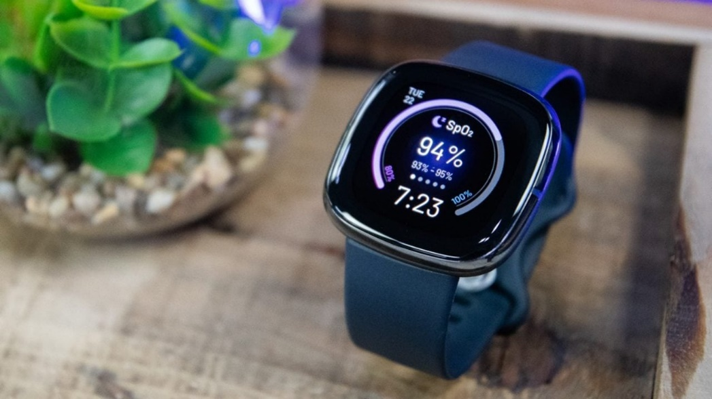I own a Fitbit Smartwatch so I can analyse its use and functionality from personal experience. The Fitbit Smartwatch is highly customizable wearable technology, making it highly adaptable, and it provides health and fitness tracking and information for the user. It requires a lot of data such as time, date, location, and personal information of the user in order to function.

It makes use of a touchscreen, side buttons and motion gestures such as twisting your arm up to read the time. It also uses an always-on sensor to trigger turning on the screen which is much more energy saving. It has a simple software interface which shows real time data and analysis however much of its hardware/ sensors are abstracted away or hidden within the overall design, making it more user friendly in general.

**What can I apply?**

I could also make use of the sensor on/off trigger since an IOT standalone device requires some well thought out energy saving features.

Also I will take into consideration the benefit of simple gestures for individual tasks to make the product as intuitive as possible and to make it simpler to understand and use.

**Gesture-controlled System:** Flutter

Flutter is a gesture-controlled program (no motion) to control media such as music or films using input through a webcam. It is supported on Windows Media Centre and other media sources such as YouTube. It has specific set of features eg. start, stop, skip etc. etc. Most importantly it is optimised for an SPI interface camera which stands for Serial Peripheral Interface. It can run at high speeds within short distances, and an SPI's data rate can go up to 60 Mbps.

**What can I apply?**

I can also include an SPI camera module for my Raspberry Pi Pico which I think will greatly improve its performance and results since it is meant for real time machine learning + image processing.

**"Stationary Robot" device:** Amazon Alexa

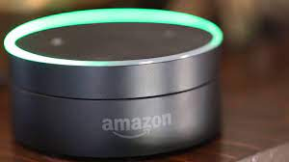Amazon Alexa is the software integrated with the much older Amazon Echo hardware, both of which are very high-level technologies. Amazon Alexa is able to synchronise with many different types of devices and draw relevant data from them and, for example, function as a media player, a smart home control hub, make/take phone calls, search the web, work like an alarm clock, record audio etc. etc. It has a very wide range of functionality and compatibility making it very versatile and helpful in many situations however it is not specialized for any particular task unlike my own product.

**What can I apply?**

It is very convenient as a small "static robot" which I will also be incorporating in my design. Similarly, Amazon Alexa is also making use of LED lights to signal when it is on/off/syncing etc. which I think could also be a helpful addition to my product since this would it much more accessible to the user to interface and understand the hardware of the product.

## **3c Market Research and Analysis of Gesture Recognition Systems**

Many modern systems have integrated machine learning into their products from auto-completion in search bars to full customer service chat-bots. All these systems follow the same method of producing results:

1. Pre-defined framework with which to store, manipulate and analyse data for specific insight, this is often designed using neural networks and therefore has high resource requirements
2. Training environment in which either:
   1. The input and output data is given, and a backend algorithm is formulated to reach this result (supervised)
   2. The input data is given, and a backend algorithm is formulated to reach it’s own conclusions, which may be adjusted after human analysis/ response (unsupervised)
3. Testing environment in which the input data is given, and output data is compared to expected output data to determine the system’s reliability and accuracy

I do not have access to high-level CPU; however I also do not want to rely on cloud services to make use of ML capable hardware. This is because my project will be reliant on I/O via peripherals and this has inherent delay and when web-scraping/ connecting to Google API, therefore I do not want had a third latency layer through cloud computing.

Due to limited resources, I will develop my own “machine learning” system which incorporates these plans using Google MediaPipe library which is a base ML system which picks up the landmarks of particular human features. I will use their Hand library to achieve 21 hand landmarks which I can then analyse. It is very well documented and kept up to date, so I feel this is a reliable dependency.

Although MediaPipe returns 3D co-ordinates, I will only use x and y (2D) co-ordinates in order to save storage space and simplify the computation required as I feel it will be unnecessary to calculate depth from the camera because:

1. Different peoples’ hands may demonstrate the gesture in different ways, and I do not want gesture identification to become dependent on that factor
2. Since the different gestures can be identified naturally from silhouettes (2D) images so I know this is a reasonable compromise

My initial aim with this system is to provide input frames (still images from video feed) and use the landmark co-ordinates to distinguish spread of the hand shape using relative distances. This will allow for variation such as hand-size, distance/ angle from camera etc. making it more adaptable.

Also, I will make sure to incorporate error value as this is a main feature in machine learning systems I have come across in my research. This will allow offset in the recognition so that there can be some limited variation in how different people perform the different gestures. The gestures I will be using are socially accepted and widely known so that they are not difficult to learn (ie. not sign language specific): open palm, closed fist, rock star, peace sign, Spock greeting (star trek) and thumbs up.

## **3d Tabular Components Breakdown**

|  |  |
| --- | --- |
| Inputs | Using Raspberry Pi Pico with camera module for image input  Possibly using relay switch or other sensor of on/off functionality (see Possible Features below) |
| Python APIs and libraries | API for python hand tracking – Google’s Mediapipe solutions are a well-trained and trusted implementation of machine vision and hand identification however it has no specific gesture recognition  API for retrieving data through google calendar, the most widely accessible and used calendar system currently for all ages and uses  In-built python libraries for retrieving data such as date/time information before manipulating data so it is suitable for output  Python API for text-to-speech (analogue) converter for the output to the user |
| Image processing + ML model | I will be using hand-tracking from google API however I will be setting up and training my own machine model to use this data feed for custom real-time gesture recognition |
| IOT implementation | Using Wi-Fi module on Raspberry Pi Pico to connect to my home router to access the internet to retrieve data with google calendar API and for any addition features (see Possible Features below) |
| Outputs | Speaker for analogue speech output, including greetings, reading out the time, the date, any pre-set gesture outputs as well as reminders and event notifications from the calendar  Will also make use of a small OLED screen and LED lights for testing purposes during the hardware set up and tests |
| Limitations | Restricted camera angle – may need to invest in wider camera angle to ease user experience and increase likelihood of successful image processing/gesture recognition  Stand-alone IOT device will be heavily reliant on battery source and other energy source implementation would requires extensive hardware changes/ additions  Raspberry Pi Pico is a simple microcontroller with hardware facilities but machine learning model might cause overheating by processing weight on CPU from high/constant resource requirements so I may have to make use of cloud-delivery for the ML vision model  Also if the user changes and/or adds new reminders/events in their calendar then the program needs to recognise this and be able to add this to the metaphorical queue of outputs and not be missed out |
| Possible Features | If "always-on" system is used then this will be constantly processing frame passively until a gesture is recognized  If "always-on" system is not used then either relay button could be used to act as an on/off switch, or a motion/light/heat sensor to automate on/off switching – so it is the only "always-on" component  Since stand-alone IOT devices need to be energy efficient as well as capable, making use of solar panel energy input could be beneficial  To broaden features of gesture recognition, I could include web scraping for news to provide user with daily headlines since important part of productivity is awareness with current events |

## **3e Graphical Systems Breakdown**

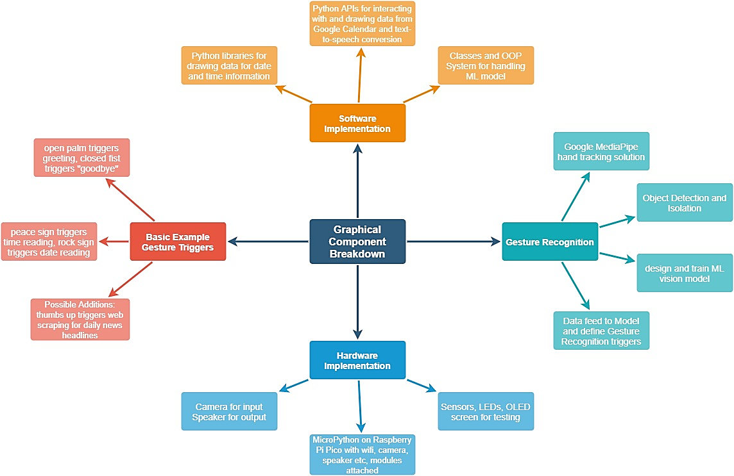

**Graphical Systems Breakdown**

## **3f Initial Data Flow Diagram**

## **3g End User Requirements/ Success Criteria**

|  |  |
| --- | --- |
| No. | Criteria |
|  | ***Google API side*** |
| 1 | Google calendar API implementation is able to retrieve all of the correct and up-to-date data |
| 2 | Data is updated periodically per unit time as decided eg. per hour |
| 3 | Database is used to store/ manage/ order the event data to ease further processing |
| 4 | Information is retrieved at the accurate output time and text-to-speech functionality works |
|  | ***Gesture Recognition side*** |
| 5 | cv2 and mediapipe library function together to process each frame for landmark positions |
| 6 | Gesture matrices are accurately built from test data and stored in accessible location |
| 7 | Error calculation method can reliably determine, and output, gesture received |
|  | ***Overall System*** |
| 8 | Raspberry Pi Pico is able to function and both camera and speaker module run well |
| 9 | Text-to-speech and audio output resource is shared effectively between the two sides |

# **4 Design Stage**

## **Diagram Description automatically generated4a Structural "Activity" Diagram – to be interpreted as graphical data + algorithms flowchart**

## **4b Decomposition of Files + Data Structures + Algorithms + APIs:**

|  |  |
| --- | --- |
| **Google Calendar Implementation** | |
| GC access and data retrieval API | – algorithm to execute this will include for regular "updates" (ie. overwriting saved data with newly retrieved data on set interval such as every hour)  – will require consideration of current time so as not to load past data/ notifications which are not relevant |
| Data cleaning | – implemented as function for every piece of data retrieval |

|  |  |
| --- | --- |
|  | – will follow set rules to reconfigure given data into more "user friendly phrases" which sounds more natural in text-to-speech |
| Data storage and recall | – since this data is inherently in a given order with set times for output, complex data structure of queue can be used alongside python time module to control output at relevant times  – this will allow for automatic time zone synchronization since python time module draws time data from the local machine OS  – python “queue” can be better implemented using OOP design which will minimize confusion in the layout and access of the “queue” implementation  – the data can be stored using python pickle module as a separate binary file which is more secure than a direct database |
| **ML Model** | |
| MediaPipe solutions framework (Google) | – live, input feed would provide full view of user/user’s hand which will be filtered to simplify data by locating and isolating hand position within the image using OpenCV to interface with real-time input  – benefits of MediaPipe solutions is that it has world-wide wealth of practice data and can work effectively in any environment, background, colour/ contrast, or lighting/ filter – so very dependable  – the only saved data is the co-ordinates of the hand contour points which are recognized by the MediaPipe solutions and can be used to draw onto the live image (beneficial for testing) |
| Personalized ML model | – implemented as secondary layer of the hand gesture recognition system in order to recognize the specific hand-gesture used in real-time  – will require a lot of testing and training data which I will provide for myself, will make use of tinyML concepts since the Pico is a micro-device  – also responsible for triggering the appropriate response to carry out the intended request of the user |
| **Trigger Processing** | |
| Python library links | – retrieval of appropriate data through stored data from .db files such as if the user makes an open palm this will be recognised as a call for greeting and one from a set group of greeting phrases will be used  – alternatively, retrieval of appropriate data may come from specific use of python libraries such as if the user makes a rock music sign this will be recognised as a call for date reading and is found via the "date" module |
| Reformatting data | – because all data output to user is through analogue speakers it must be in such a format that is more natural when "speaking" as opposed to written to be read by the user as most devices work currently  – reformatting will require specialized algorithm to work with a given expected input format and always return a set output format; regularity is most practical to code and most reliable method of implementing an automated algorithm |
| **Output** | |
| Text-to-Speech – Google API | – every output of the full program will be required to pass through this so I could implement this as a standalone algorithm which is available to access from any part of the program  – all data at this point will be strings therefore individual reformatting is required to ensure a smooth transition from digital to analogue data |

## **4c Restatement of User Req. as Design + Testing Objectives**

|  |  |  |
| --- | --- | --- |
| No. | Criteria | How it will be tested |
|  | ***Google API side*** |  |
| 1 | Google calendar API implementation is able to retrieve all of the correct and up-to-date data | View web interface and script output side-by-side |
| 2 | Data is updated periodically per unit time as decided eg. per hour | Demonstrate mechanism within code and if possible show periodic database entries |
| 3 | Database is used to store/ manage/ order the event data to ease further processing | Explained through written code and screenshots how the db is implemented |
| 4 | Information is retrieved at the accurate output time and text-to-speech functionality works | Video of pop-up output at specific expected time to show evidence |
|  | ***Gesture Recognition side*** |  |
| 5 | cv2 and mediapipe library function together to process each frame for landmark positions | Screenshots to demonstrate MP output on live camera feed |
| 6 | Gesture matrices are accurately built from test data and stored in accessible location | Screenshot filing and database system used |
| 7 | Error calculation method can reliably determine, and output, gesture received | Screenshots of input images, then expected and actual response comparison |
|  | ***Overall System*** |  |
| 8 | GUI is sufficient to demonstrate the functionality (not a direct objective) | Screenshot of working desktop UI running full main program |
| 9 | Text-to-speech and audio output resource is shared effectively between the two sides | Main program explained via code and then possibly further video evidence |

Due to sourcing issues with Raspberry Pi Pico and greater importance on efficient and reliable backend software, I have decided to follow through with a Proof-of-Concept Method and leave out the Raspberry Pi Pico. Instead I have decided to demonstrate functionality and user access with desktop UI, I will explain my decision further later on in the development process (*5c*).

## **4d Test Strategy Planning**

### **Testing During Development**

Criteria have been segmented (see previous page) with general testing requirements in order to validate the success of that particular task within the full program while carrying out iterative development – ie. combining segmented modules/ subroutines to build up a prototype on which testing and improvements can be made – and validating at every intermediate stage.

Large proportion of input data in this program will be graphical vector data (images), so it is difficult to demonstrate trace tables for these processes. This means a higher testing workload during development and more subjective/ complex testing requirements, however, resulting in majority of changes only being small edits due to the nature of the program as a whole. So a more in-depth testing plan is in place for post-development (see below) to ensure the quality of the final product.

### **Testing Post-Development**

1. **Performance Testing:**

A) Test that Google Calendar implementation works by setting up series of fake tasks/ reminders at set times and testing:

* 1. the accuracy and delay in the data being output via speaker
  2. the clarity after cleaning and reformatting into strings
  3. the effectiveness of the output as response to the user’s expectations

B) Test the ML model system and surrounding algorithms by inputting real-time gesture data via camera module and testing:

* 1. the reliability of the camera input and the intermediary stages of data cleaning and preparation for recognition
  2. the accuracy in recognition of the gesture, and in turn triggering the correct output
  3. the effectiveness of the output as response to the user’s input

1. **Acceptance Testing:**

**Final Questionnaire for all users:**

1. Do you feel that this product has benefitted you beyond the other time management tools/ methods you use? And how/ why?

2. Do you feel this product has benefitted you in conjunction with other time management tools/ methods you use? And how/ why?

3. Can you specify some positive features of the product? Expand on your experiences:

4. Can you specify some negative features of the product? Expand on your experiences:

5. In what situation would you consider this a useful/ helpful product to have? (eg. a type of person/ environment/ job etc.)

6. What do you feel is something that is missing from this product and/ or something that shouldn’t be a part of this product?

**Justification:**

Q1-2: to better understand the user’s impression of the product their overall experience

Q3-4: to gain deeper insight into the user’s experience with using the product

Q5: to collect information on how to take the product forward as in real life projects

Q6: to get general feedback on the product’s range of features and uses for the specific user

# **5 Development Stage**

**Any success criteria references in this section are links to the final testing where they are assessed.**

In order to show different sides of development I will describe the stages for google calendar API integration and I will analyse the (somewhat) final product for gesture recognition system.

## **5a Development stages for google calendar API**

Initialised a google cloud project via google development platform with calendar API access

<https://developers.google.com/>

### **Initial Stage 0**

Authorised my google project with OAuth identification key which requires re-calibration every seven days via user access (python script)

<https://console.cloud.google.com/>

gCalSetUp.py

àtakes “client ID” access key from above from json file and runs google authentication library

à flow.run_console() is able to return webpage link in order to “re-calibrate” authentication for the given user from which a key is copied back and stored in a binary (pkl) file called “token”

gcalAPI.py

à starting lines of API integration via OOP – you can see the token is used as credentials to build a “service” object to interact with the google calendar API

**Review:**

At this point I have a working connection to the google calendar API which I will now be able to write functions for collection and cleaning of calendar data.

### **Development Stage 1**

To familiarise myself with API system and python library syntax I experimented with how to make and retrieve events and how event data is organised/ stored/ accessed.

Now saved in reference.py

**Review:**

From this experiment I was able to understand how data is handled within the google calendar system, how to reference different event data and how to use the google calendar pre-written API.

Using this I will be able to implement object-oriented programming in order to make functions which are able to interact with the google calendar API and effectively perform web-scraping to handle the event data from my personal google calendar. I will build these functions onto the existing gAPI class structure written in stage 0.

I plan to write two functions:

1. “returnData” which will return raw data via python’s google calendar library as shown above and this will include data on all event types (normal, all-day and reminder type)
2. “cleanData” which will parse through this data and return only the useful information in a simplified, concise tabular format (2d array)

### **Text Description automatically generatedDevelopment Stage 2**

**Testing for this module:**

|  |  |  |
| --- | --- | --- |
| **Problem** | **Change** | **Explanation/example** |
| Initially, I wanted to read eventData from all the daily events, but it was difficult to design query to only pick up events which start in range | Tested many variations of midnight (00:00:00) and working with datetime module to input the current date (today and tomorrow) | The service object is able to return data stored in google calendars from within a time range where timeMax means latest start time and timeMin means earliest start time |
| I then decided to only draw event data for upcoming events (start time in future) to reduce processing complexities in later functions | Changed the timeMin to fit the requirement but some trial and error was required to understand the correct format | I made use of python datetime library to provide current date and time details such that only events after the current time are taken from my calendar |
| In Britain we follow two different time zones at different times of the year, so this affects the current time required for the query as this is independent of the clock time | Needed to automatically handle change in clocks (GMT vs BST) by assigning offset -variable to denote change in current time | Offset variable was required to correct time range in the service query so utilised datetime module again to get current data |

Testing involves running the program with variety of fake events to judge accuracy of output.

Eg. google calendar test events via google web interface:

Event which crosses over to previous/ next day

Reminder type events of 0 length

all-day event with no time data

Random events of variable length

Time of test: 15:30



As shown above, returnData function is able to accurately return the information on the events/ reminders provided in the google calendar system by the user (in green) . However one limitation is if the event currently running this will also be picked up (in red) even though it started in the past, this will have to be dealt with in the cleanData function where I will have to make a final check.

**Testing for this module:**

|  |  |  |
| --- | --- | --- |
| **Problem** | **Change** | **Explanation/example** |
| Variation in event types requires more complex processing | Assigned empty list to “eventData” variable | “all-day” and “normal” events can both be processed in the same function |
| Variation in formatting for start/ end times, duration, reminder (time before) will be too complex to manage later | Line 64-83 is purely for formatting purposes in order to make data more directly useable | Since the API system uses 24hr notation, more checks are needed to ensure duration and reminder information are accurately represented |

Shown above is the given test data which has now been cleaned (+ ordered) to the following format:

(“name”, “start time”, duration hrs, duration mins, reminder time in mins, all-day or not)

**Review:**

Due to how the functions work as part of OOP design it will be more effective to use a database with binary storage (more efficient) to handle this data over time since my project will need to store and reference this data at specific/unplanned times of the day. Therefore, now that data has been organised in tabular format, I will insert the data such that each row represents an event.

**THIS IS PROOF OF SUCCESS CRITERIA 1**

### **Development Stage 3**

**db_init.py**

Using SQLite python library I was able to write SQL syntax from within python in order to initialise a flat file database (single table) to store cleaned and organised data.

I used the pre-written methods within the class structure as re-usable code. This is efficient because it will be the same process every time so I can rely on my functions since they have been tested already.

**Review:**

This was very simple to write, just some application of sqlite3 library and query syntax. Not much testing involved as I was relying on pre-written functions above which I had pretested and defined the database accordingly to match data types etc. etc.

Now the main task is to work on how to make use of these functions in an effective way which allows me to build on the output side of the project as a whole.

### **Development Stage 4**

I plan use google text-to-speech library to form audio files which can be output via any type of speaker; however this has more demanding storage requirements, and I don’t want to rely on naming and storing many audio files since they demand more space. Instead I will add to my initialisation program to define a new database only for the output files and I can store my short audio clips as binary file.

**Review:**

Made use of my pre-existing knowledge on sqlite3 database syntax and the module structure of my program. Now all output files (short audio clips of the event message containing google calendars API data) will be read out by Google’s open-source library “google text-to-speech” and will be saved in the database as binary file using “BLOB” datatype. It essentially signifies unknown/unspecified datatype, which is a unique feature of python’s sqlite3 library, allowing me store audio files as binary data and read/ write directly from within python (which has binary data conversion built in). I can now use this as my goal in the next stage.

### **Development Stage 5**

In this stage the goal is to fulfil the “output_files” database created previously, which contains the file name, audio data in binary format, length, and time to output the given message.

**Testing for this module:**

|  |  |  |
| --- | --- | --- |
| **Problem** | **Change** | **Explanation/example** |
| Initially I wrote separate methods for processing and inputting the data into the “output_files” database but this was inefficient and slow | Merged the two methods in order to simplify the code and avoid carrying arrays of data across as arguments | This was still a reliable decision as the code required to complete these jobs isn’t going to be needed anywhere else and there is a lot of data being handled in this algorithm |
| I needed to plan when to output each message in terms of order without having all the audio files readily loaded | Taking advantage of database structure of adding new records in queue like order (LILO ie. input at the “end” and output from the “top”) to organise and keep track of timing of the events | This simplified the algorithm since the events where already drawn in order from the google calendar API and stored in the same order in “events” database |
| Came across issue of “deciding” what time to output each event message or if multiple different messages were required | It was most intuitive use of the data to output twice, once at the time of the reminder (reminder time) and once at the time of the event (actual start time) | I found this to be successful strategy as this would benefit both people who like to be prepared in advance and those who need a reminder to get going at the right time since I relate to this issue a lot |

Here I have used <https://sqliteviewer.app/> to view the contents of my SQLite database files, which shows organised and easily accessible data storage and management.

cal_data.db :

output_files.db :

It is in the reverse order for cal_data so that it can be entered into output_files in the correct order (somewhat following stack system from cal_data to queue system in output_files)

**Review:**

Since my method is to store two audio messages for each event, this means there will be double the amount of audio data than expected. Therefore in order to manage the “output_files” database I will design the output algorithm in such a way that it minimises on storage demand and maximises on efficiency and is able to be run stand-alone and handle errors such as an empty database etc. etc.

**THIS IS PROOF OF SUCCESS CRITERIA 3**

### **Text Description automatically generatedDevelopment Stage 6**

**Testing for this module:**

|  |  |  |
| --- | --- | --- |
| **Problem** | **Change** | **Explanation/example** |
| Although some events are in the future their reminder may be in the past which is impossible to output on time | Had to introduce an extra layer of confirmation to check whether an output message is valid before matching to the current time | If I were trying to compare a timestamp for an output message in the past this would cause an endless loop |
| The audio for each message would cut off suddenly and Microsoft Music Player (audio app) would close abruptly | Initially spiralled down a research hole to find out how to control external apps before simply attempting to elongate the waiting time till the python script cut off the audio app | I released this was because the mp3 file had finished running so the app closed and python script took over faster than the audio could finish naturally making it sound unnatural |

**Review:**

At the end of this stage I now have a full working and tested prototype of OOP approach to collecting, cleaning, storing, and handling google calendar data via API authorised web access. The next steps include testing for user feedback and further modifications for improvements.

The following video evidence utilises the same example input shown at the start of development phase. Video evidence of Google Calendar Implementation: <https://youtu.be/JI1NyUE9ZFc>

**THIS IS PROOF OF SUCCESS CRITERIA 4**

## **5b Demonstration of Algorithms + Approach used for Gesture Recognition**

**hand_class.py**

every image file is saved with a unique name therefore well-organised

“IMAGES_PATH” is pre-set variable which leads to folder containing training images

“labels” is pre-set list of gesture names used for iterating over and naming files

HandModel class used to implement OOP structure

constructor used to access all MediaPipe solutions from every method

these methods were built to improve efficiency, organisation, and usability of the program since they are re-used many times – reduces debugging time

training images are used to cumulatively build a dataset for a particular gesture and then find average which represents a specific signature within each matrix saved for reference later in binary files

after a pre-set average gesture matrix is fetched then an “error” value can be found as the sum of differences between them

purpose of normaliseMatrix method is to overcome challenge of variable distance from camera/ size of hand problem which is unpredictable factor of the user

these methods work in tandem to provide matrix of distances between pre-determined “keyPoints” which reduce the dataset to only include meaningful data.

**Evidence of Gesture Matrices and filing approach**

I did not use a database as I decided secure binary files to be the most effective method as shown:

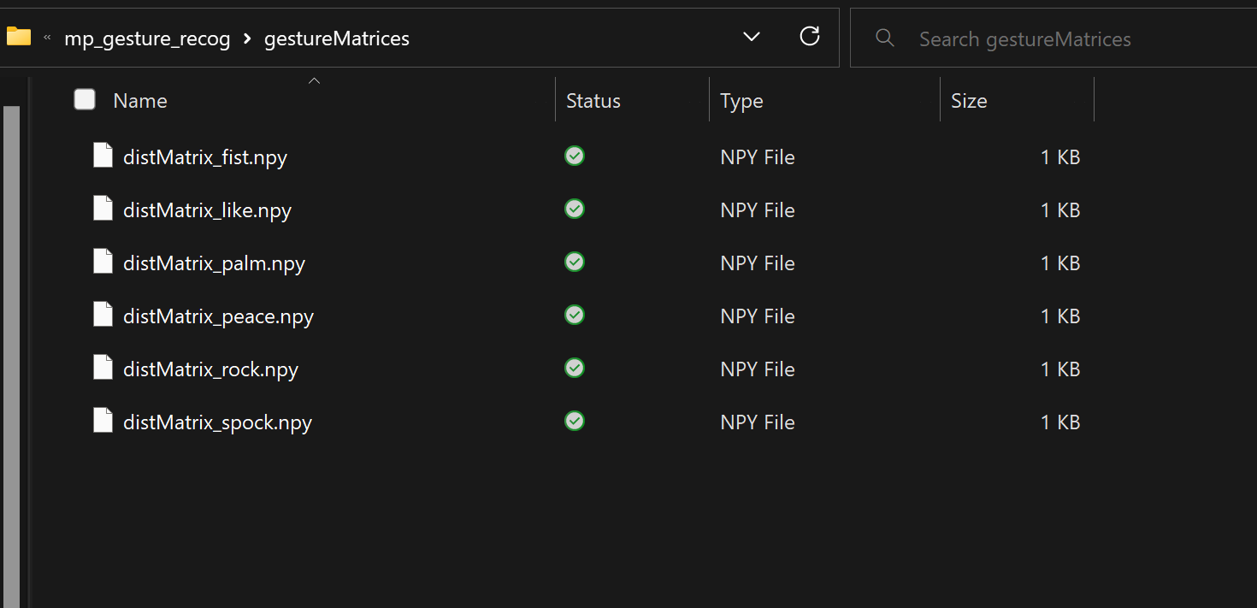

Why:

1. Dense, repeated numerical data is most efficiently stored in binary files which can then be accessed as needed and read when called to via numpy function call
2. It is more secure and requires specific commands to be opened/ read from/ written to therefore less risk of accidental editing and/ or deletion

Example file shows normalised landmark distances between each of the chosen key hand landmarks:



Diagonal of “0”s can be seen which represents minimum distance between the equivalent hand landmarks – in reality this is actually 0 distance.

Additionally, the number 100 can be seen showing maximum distance between two different hand landmarks – in reality this is a small number measured as distance in pixels between image co-ordinates, but it is 100% of the normalised distance so the biggest.

Downfall of this method is repeated data since the file represents a two-way table of values, however, this layout ensures it is easy to refer to each value when calculating error and it is the same for each pre-set gesture matrix.

**THIS IS PROOF OF SUCCESS CRITERIA 6 AND 7**

using pre-defined 2d array of “options” to link necessary data, this method brings together the previous methods in order to provide a “bestMatchOrder” of the “options” to the current unknown gesture

**setUp.py**

simplified program draws from “HandModel” class to:

1. collect and organise training images using “collectImages” method
2. iterate over this data to build and normalise pre-defined gestures using “setGestureMatrices” method

**main.py**

**THIS IS PROOF OF SUCCESS CRITERIA 5**

main running loop which is used to continuously update and determine which gesture is being performed by the user using “deterGesture” method

written description of recognised gesture is given on the live feed

base case is defined to ensure the camera can be released and loop is finite

### **Text Description automatically generatedHand Detection System Explained**

I have designed my algorithm to be dependent on spread of the hand shape, not on distance or hand size, angle, depth from the camera, or left/right hand detection - making it much more robust when testing.

### **Breakdown of Testing Process**

**Training**: involved working on improving prototype for variation of pre-determined gestures in different environments.

To ensure my training data was not affected by external/ irrelevant factors, I introduced as much variation as possible while keeping strictly within the acceptable range for the recognition algorithm. In general, I have written a trace table to show the variation and resulting capability of my program:

|  |  |
| --- | --- |
| **Type of variation** | **Successful outcome?** |
| A person holding the hand up  Description automatically generated with low confidenceClear and bright (normal) |  |
| A person holding up the hand  Description automatically generated with medium confidenceA person holding their hand up  Description automatically generated with medium confidenceDull lighting/ colour-tinted |  |
| Far/ close up |  |
| A picture containing person  Description automatically generatedangle/ tilt of hand |  |
| A person holding their hand up  Description automatically generated with low confidenceImage clarity (ie. introducing movement) |  |
| A person holding the hand up  Description automatically generated with medium confidenceRight hand |  |
| Left hand |  |

This is effectively an all-round representation of my training data

**Testing:** as shown in real time, can be seen in the following video evidence: <https://youtu.be/RZT1R_ElcfM>

In particular:

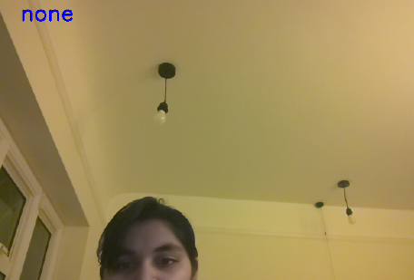First image shows algorithms response to lack of any hand landmarks detected at all whereas second image shows response to an error in recognition or insufficient similarity to pre-written gestures à responsive error handling

## **5c Short Mid-development Questionnaire**

My original plans were hindered by my lack of resources and need to focus on meeting the success criteria as restated during test planning. Therefore I decided to consult my stakeholders for advice on following Proof-of-Concept Method via desktop UI.

1. What general features are needed to demonstrate proof-of-concept?
2. What extra/ supporting UI features would be beneficial to include?
3. What additional design considerations should I keep in mind when creating the UI?

I used these questions to understand, as potential users, what they would want to see in, effectively a prototype, of the project and how proof-of-concept method would play out.

### **Responses**

**Feedback in terms of proof-of-concept:**

Person A was very directed towards simplicity, making sure the original I/O systems were demonstrated separately but ran concurrently and efficiently as well. I plan to use threading in order to achieve this, and resource locking (similar to record locking in databases) in order to manage the shared I/O resource (audio output).

Person B mentioned using performance modelling alongside a Raspberry Pi Pico sim to strengthen my proof-of-concept argument. This can be implemented as an additional testing phase and further expanded on for future development in evaluation section.

**Feedback in terms of UI development:**

Person A said that a limitation of the original design was no user directions/ guide (although this could have been implemented physically when designing the final end product) so I should use this opportunity to provide the user with a basic guide on inputting data (ie. hand gestures). They also mentioned real-time user feedback as a way to making the system more user-friendly.

Person B was eager to see calendar details in some way since this would make a productive and relevant use of space on the screen and add baseline functionality (even though this is not the final product).

In summary, I will be using tkinter to build a simple graphical interface, this is another well documented and maintained library which contains many specialised sub-libraries which I can use to achieve specific outputs/ GUI elements.

### **Summary**

**Therefore my overall GUI will incorporate:**

1. A camera feed to make it obvious the gesture recognition system is running
   1. This will pause when a gesture is recognised, and the speaker is outputting audio
   2. In attempt to make it more user-friendly as suggested I can also output on the screen if unknown or unclear hand gesture is being provided to prompt the user to adjust their particular input
2. A gesture guide to show the accepted hand gestures and their output
   1. This should help the user better understand the functionality of the product and being able to make full use of the system
3. A calendar widget which is simply a pre-designed widget within tkinter
   1. I will also program a button to “jump back to today” to make it more intuitive

## **5d Planning GUI Layout**

**Camera Feed**

**Gesture Guide**

**Calendar Widget**

**“today” Button**

**Gesture Guide**

**“today” Button**

**Calendar Widget**

**Camera Feed**

Final layout:

1. I will put camera feed in the top left as this is where people look first and will bring the most focus to this element (as shown in layout 1)
2. I will use horizontal gesture guide and vertical calendar widget + button as these seem most balanced on the page and can easily form a segmentation of the page which seems more organised to the eye (as shown in layout 2)

## **5e Development of Main Program**

### **Initial Stage 0:**

1. Combine main programs of gesture recognition and google calendar API systems
2. Make use of threading in order to run both constantly and use I/O locking to manage shared resource via threading events (inherently global but private variables)
3. Set up web-scraping/ python library calls to return information for gesture triggered outputs

My initial plan:

### **Text Description automatically generatedDevelopment Stage 1**

Starting off with all the necessary imports required and initial tkinter setup for a simple GUI.

“gesture_guide.png” is a word document screenshot of the gestures and pre-assigned outputs.

The exact design, layout and sizes will be changed this is just an initial set up.

### **Development Stage 2**

I then implemented the threading system and moved all of these “main” parts of the main program into its own section:

Local instances of the prewritten classes are initiated here to reduce arguments required when calling functions/ defining threads

This is used to set a default calendar date and be able to reset it when the user chooses to (via button)

“audio” is set up as a threading event which is a subclass in the threading library

### **Development Stage 3**

When implementing the two systems as functions, I copied the pre-written programs and added conditions to check if audio event was set (ie. locked) or not before outputting audio.

Since every upcoming event creates both a reminder and “now” message, a final check is needed to confirm if it is in the future – for example an event in ten minutes (valid) could have a reminder 30 minutes before hand (invalid) so all messages must be checked and deletes once dealt with in some way

**Review:**

By this point, I have successfully built a GUI interface capable of pulling and organising event data from google calendars for text-to-speech output. Further development will focus on setting up feed with live gesture recognition as well as implementing shared audio resource between them.

### **Text Description automatically generatedDevelopment Stage 4**

shared I/O resource between the two threads is handled by common function

**Testing for this module:**

|  |  |  |
| --- | --- | --- |
| **Problem** | **Change** | **Explanation/example** |
| Pausing camera feed during audio output in order to stop gesture recognition | Making use of time.sleep() in the audio_out() function in to stop any camera frame update | Using time.sleep() will cause the thread to hang for the duration of the mp3 file so that the camera cannot be updated |
| Jittery camera feed output compromising effective gesture recognition | Although the camera feed is updated twice in the same loop it was much more efficient to not use a separate subroutine because of the delay | Before the if statement is required to show the gesture before triggering output, after the if statement it is required to update message |
| Unknown vs none for user feedback | Had to separate out the if statement in order to distinguish whether a hand was present in the frame or not | Only wanted to output “unknown” on the camera feed if an unrecognisable gesture is given but not when no gesture is given at all |

### **Development Stage 5**

I then wrote the “close()” function to make sure both methods of closing the tkinter application resulted in a “clean” exit (ie. all the unused files deleted, and camera connection closed).

 In order to provide useful audio outputs for each gesture I then when back into hand_class.py and wrote a new method in order to fulfil this function call from above:

Although this is a repeated routine (also used in google cal. side) which could have benefitted from modular design, they required different return criteria, so I felt it more appropriate to keep the two sides separate

For those outputs which required web-scraping/ library dependencies, most efficient method was to isolate delay using if statement

New method written in previous class for MediaPipe integration

# **6 Evaluation**

## **6a Post Development Final Testing**

The following testing will be used to inform and justify evaluation, as planned prior to development:

1. Performance testing 🡪 to test the separate and ultimately combined main program on performance factors such as speed, accuracy, clarity, efficiency etc.
2. Acceptance testing à to test the features and usability of the overall product from the potential user perspective (ie. stakeholder feedback)

### **Performance Testing**

The following evidence demonstrates several calendar events and hand gestures being handled and the resulting output of the main program.

<https://youtu.be/TUVfeoefOTU>

### **Summary**

|  |  |  |  |
| --- | --- | --- | --- |
| **Key points** | **Expected outcome** | **Actual outcome** | **Notes** |
| Google calendar reminder TTS output | On time, clear and simple to understand |  | This was test 1 – exactly on time as shown by on-screen clock |
| Google calendar event TTS output | On time, clear and simple to understand |  | This was test 2 – exactly on time as shown by on-screen clock |
| Google calendar future event TTS output | Clear instructive information, only necessary/ useful information provided |  | This was test 3 - provided only useful information was how much time left and time and duration of the event – in fact even more on time than windows notifications (see last 30s) |
| Gesture recog. pre-set output (palm) | Immediate, clear response |  | Slight delay due to being first mp3 file therefore having to wait for audio player to launch |
| Gesture recog. non-pre-set output | Minorly delayed, clear and sensible response |  | Example of at least one headline, weather, exchange rate and Spock message shown in the video |
| Gesture recog. pre-set output (fist) | Immediate, clear response resulting in clean termination of the program |  | Final gesture before termination, the red highlighting shown is syntactical and does not show any error |
| GUI proof-of-concept usability | UI is clear and simple to use |  | See image 1 below |
| Additional features | They are non-invasive and actually useful |  | See image 2 below |

**Image 1**

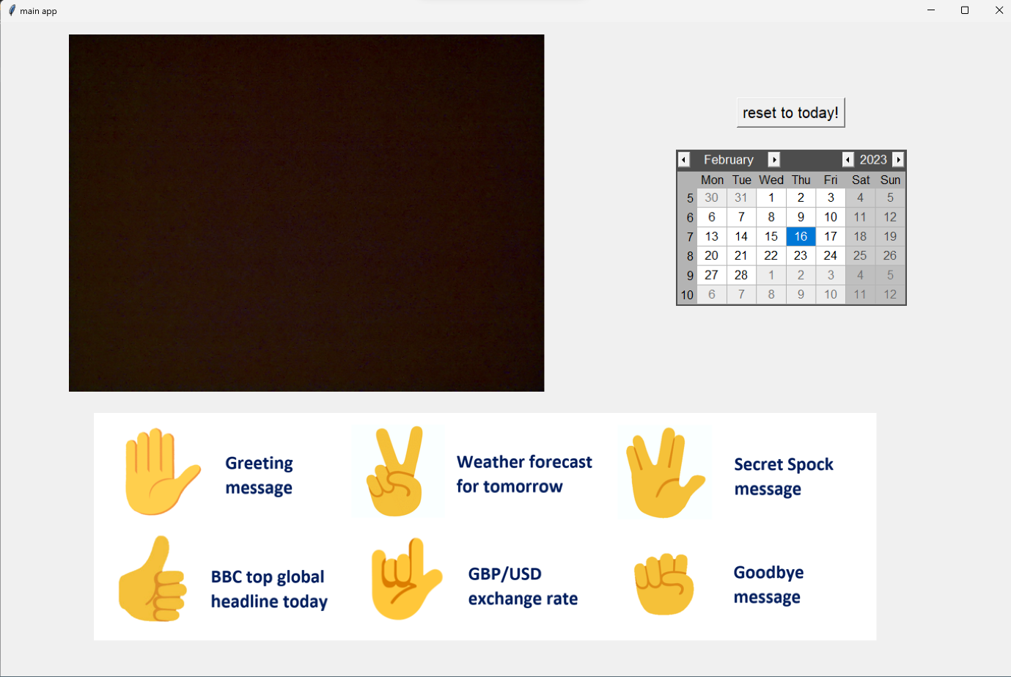

Font size, buttons etc. are clear and intuitive to use

**Image 2**



Calendar widget use shown in the video as well as “today” button

### **Acceptance testing**

The following questions were designed in the initial testing plan before development took place:

1. Do you feel that this product has benefitted you beyond the other time management tools/ methods you use? And how/ why?

2. Do you feel this product has benefitted you in conjunction with other time management tools/ methods you use? And how/ why?

3. Can you specify some positive features of the product? Expand on your experiences:

4. Can you specify some negative features of the product? Expand on your experiences:

5. In what situation would you consider this a useful/ helpful product to have? (eg. a type of person/ environment/ job etc.)

6. What do you feel is something that is missing from this product and/ or something that shouldn’t be a part of this product?

I feel that although the outcome of my project has changed (a GUI prototype has been developed instead of a standalone IOT device) this set of questions can still be used to gain important insight into the final product in terms of software features and functionality from the stakeholder (ie. potential user) perspective.

**Person A:**

They were pleased to find that despite the prototype making use of desktop GUI, none of the functionality was dependent on it and they could make use of the product without looking/ when forgetting to wear reading glasses etc. which means they were able to work more efficiently.

However, they also highlighted that “more proactive use of colour would suit partially blind/ visually impaired people” better in terms of UI design which would be required if, for example, the project was implemented as a smart watch/ on-the-go device.

**Person B:**

They were clear about the value of the product as it is a “hands free extension of the google calendar interface” meaning it was more assessable and adaptable to different circumstances. They found it to be much more effective than manually looking up/ setting up lookup tools and having to keep track of time independently.

They also highlighted major benefit of how it has reduced their time wasted scrolling social media/ newsfeeds etc. for latest information. However, they also mentioned an improvement being customising/ deactivating the outputs of the particular gestures (ie. personalisation). They considered personalisation to be the main feature to be lacking in the product because this is most important factor in people’s personal working style/ routine etc.

### **Summary**

Both stakeholders were able to see the hands-free/ screen-independent value in the product and both found it to be of value in everyday life including outside of working hours when you just need an update, hear about upcoming events/ notifications, or want to hear the latest news, for example. Both stakeholders were also satisfied with the proof-of-concept turn taken during development and the subsequent use of desktop UI despite a key element of the design being no graphical interface.

Therefore I feel that the project has been successful in terms of usability from the potential user perspective, considering the adaptations which had to be made.

|  |  |  |
| --- | --- | --- |
| **Success Criteria** | **Reference/ Explanation** | **Fulfilled?** |
| **1**  Google calendar API implementation is able to retrieve all of the correct and up-to-date data | Shown during development, test input via web interface and resulting output in console window | 360 Checkbox Symbol Question Mark Icon Set Illustrations & Clip Art - iStock |
| **2**  Data is updated periodically per unit time as decided eg. per hour | At the current stage, event data is updated once the current events have been dealt with (ie. at the start of each day), this needs to be worked on to ensure updates every 30 mins – 1 hr | 360 Checkbox Symbol Question Mark Icon Set Illustrations & Clip Art - iStock |
| **3**  Database is used to store/ manage/ order the event data to ease further processing | This has been explained through written code and screenshots on how the db is implemented during mid-development testing stages | 360 Checkbox Symbol Question Mark Icon Set Illustrations & Clip Art - iStock |
| **4**  Information is retrieved at the accurate output time and text-to-speech functionality works | Video evidence was provided to show specific output with on screen clock to demonstrate accuracy | 360 Checkbox Symbol Question Mark Icon Set Illustrations & Clip Art - iStock |
| **5**  cv2 and mediapipe library function together to process each frame for landmark positions | Video evidence was used in development to demonstrate mediapipe output on live camera feed | 360 Checkbox Symbol Question Mark Icon Set Illustrations & Clip Art - iStock |
| **6**  Gesture matrices are accurately built from test data and stored in accessible location | During development, use of binary files were explained and justified for storing and accessing gesture matrices in order to be referred to within gesture recognition | 360 Checkbox Symbol Question Mark Icon Set Illustrations & Clip Art - iStock |
| **7**  Error calculation method can reliably determine, and output, gesture received | Code was explained and testing breakdown included many screenshots to show variation and capability of the API, as further shown in video evidence | 360 Checkbox Symbol Question Mark Icon Set Illustrations & Clip Art - iStock |
| **8**  GUI is sufficient to demonstrate the functionality (not a direct objective) | As this is subjective feature of the program it can always be improved with more user feedback, also GUI was in proof-of-concept methodology therefore I consider this a successfully fulfilled compromise | 360 Checkbox Symbol Question Mark Icon Set Illustrations & Clip Art - iStock |
| **9**  Text-to-speech and audio output resource is shared effectively between the two sides | Main program planning and development explained how the use of I/O locking and final video demonstrates well managed audio resource in full program | 360 Checkbox Symbol Question Mark Icon Set Illustrations & Clip Art - iStock |

## **6b Final Assessment of Success Criteria**

Evidence of each success criteria referenced during Design Stage is condensed here. **SEE KEY BELOW**

**System Requirement Assessment Results Key**

Majority of criteria were successfully fulfilled showing overall success with the project development goals.

Some future development goals can be drawn from the remaining results.

No completely unfulfilled criteria showing no neglected success points and all-rounded approach to development and testing.

## **6c Overall Project Review**

### **Limitations**

* Not on Raspberry Pi
  + Due to changes in the success criteria to adapt to hardware difficulties (as explained previously) a major limitation is the GUI interface as alternative to Raspberry Pi Pico
  + Main program was intended to run on Raspberry Pi Pico, therefore in terms of future development, the main project will require I/O facilities (camera and speaker) as well as Wi-Fi module to connect to the internet to retrieve google calendar and web scraping data
  + After developing a fully working system, it is clear this project has a high storage demand therefore Raspberry Pi system would also have to manage this either with:
    - On-board physical storage of reasonable capacity however this will require high speed as image analysis per camera frame is a very fast process
    - Online (cloud) storage which is somewhat unlimited storage in this sense because a single user using this product will not overrun, for example, free google cloud storage limits however this introduce a new issue of security and privacy for the user which would have to be dealt with
* Software dependencies
  + The program requires several python libraries in order to run such as for interacting with google calendars and managing that data with SQLite, performing frame-by-frame mediapipe gesture recognition, real time audio output, web scraping for gesture outputs etc. etc.
  + have managed to set up all of these dependencies without requiring any specific user details/ data apart from google calendar API which is inherently covered by google themselves and the user’s original google account contract
* “eventData” update issue
  + Event data does not update periodically as stated in the requirements, and this is a hinderance to the user as the program will not be able to sync with any updates made on their Google Calendar during the day
  + Currently, “eventData” is recalibrated when the current run of synced events finishes therefore at minimum automatically by the end of the day, however it can be manually recalibrated whenever the app is closed and restarted (not minimised)
  + I have spoken more about how I would work on this in future development goals, see below
* Initial/ different user Log In
  + Currently in order to access google calendar API I have used the project system provided by google to run an authentication before drawing data which requires reconnecting every 7 days
  + Under the assumption there would be a single end user using a standalone IOT device (Raspberry Pi Pico) I did not plan or design any direct log in system which in hindsight would have been the appropriate approach
  + In the main code, the “gCalSetUp.py” can be used to log in via any google account available on the device to authenticate the API however this is a manual process, and an improvement here would be to add it to the main program in some way
* Error Handling
  + In an effort to complete the success criteria and produce a full working program I have neglected to include the error handling required to deal with the uncommon issues even though they may seem trivial such as:
    - unstable/ insufficient/ inconsistent internet connection leading to inability to draw google calendar data and/or web scrape for gesture outputs
    - weak/ interrupted connection to google calendar API resulting in empty event data
    - camera/ speaker module fault/ error (in terms of both software and hardware) meaning frames cannot be processed or audio cannot be output
    - etc. etc.
  + These features make up the basis of the whole program and will require more attention in future development to ensure reliable system, see below

### **Accessibility**

* Independent of the GUI
  + Main program is able to function independently of the GUI interface ie. minimising the window will not hinder any functionality
  + This allows for more freedom in how the user uses the product and more adaptability for different working styles/ layouts
* The GUI interface does not require any input/ output from the user
  + Although the proof-of-concept method introduced a digital screen into the solution which was the main interface I wanted to avoid in the initial proposal, I made sure to fulfil my overall aim of helping visually impaired people
  + Therefore my project still fulfils the initial goal I had to produce a productivity tool which helps visually impaired/ partially blind people where the interface does not depend on typed input/ written output
* Adaptability in future Application
  + due to the current version of the program being a fully functioning desktop app with minimal GUI, the applications of this program are wide depending on the path chosen, for example, could be embedded into smart (possibly wearable) devices, could be built into desktop systems, could be placed anywhere around the house

### **Maintenance**

* Many software dependencies
  + To help deal with libraries/ APIs needed, I have written a requirements.txt file to manage which ones have to be installed
  + These are needed in order for the main program to run smoothly and for all functionality to be accessible on a new device
* No backup/ error message
  + Although minor error handling is used in the main program, initially raw data from gCal API is manipulated and stored for audio output
  + Any error/ corruption/ incomplete information could possibly cause problems further in the in the program or confusion for the user, so this needs to be dealt with
* Many data requirements
  + Another problem which could cause unwanted damage to the usability of the program is deletion/ corruption of the core files necessary for the main functionality to run
  + This includes the google calendar token, json project key, calendar databases, gesture matrices etc. etc. - see below for how I would deal with this

## **6d Future Development Goals**

|  |  |  |
| --- | --- | --- |
| **Goal** | **Actions** | **Aim** |
| **1**  Implement Raspberry Pi Pico as Main System | - plan out my time better, make use of project management tools to achieve this  - prepare more raspberry pi knowledge in advance to be able to fulfil initial criteria  - research more into existing solutions to build more cohesive/ adaptable solution | Limitation Improvement |
| **2**  Improve gCal system to update event data periodically | either - introduce a new variable to control “time since last update” or reverse and force update periodically or - adapt the original function to only receive event data from the coming hour leading to minimum of hourly update | Limitation improvement |
| **3**  Produce automated script for installing dependencies | - automated script will have to have administrative authority so the program would need user permissions so that it can check and install dependencies before running  - this will save time for the user and increase ease-of-use | Limitation improvement |
| **4**  Introduce log in system | - this will allow new users to log in with new google account, and existing users to recalibrate the calendar API or change accounts  - if Raspberry Pi Pico is used as the main interface, then an initial GUI setup may be required to fulfil this criterion | Limitation improvement |
| **5**  Ensure error handling throughout | - implement error handling to automatically deal with initial or sudden loss of connection to API, google calendars, physical modules etc. with appropriate error message and restart the app | Limitation improvement |
| **6**  Setup error message and output for missing/ incomplete calendar data | - this will remove risk of crashing/ buffering/ lagging when data transmission from gCal API is unable to communicate clearly  - this will improve user accessibility as someone who does not have specialised knowledge and is not able to understand/ fix the problem will not be left with a faulty program | Maintenance improvement |
| **7**  Setup backup system for important files | - important files include the gesture matrices (binary) files and the calendar databases (both cal_data and output_files)  either - an automated script for rerunning the code which reproduces these files  or - an online available copy of the files could be provided for users who have accidently deleted/ corrupted it | Maintenance improvement |

These would be the second iteration success criteria if I, and/or other developers, were to pursue further development for this project in the future.

# **7 Full Project Link**

Here is link to the full project as a read-only private GitHub Repository hosted on [https://gitfront.io](https://gitfront.io/):

<https://gitfront.io/r/TamannaKar/tZVjAX9H7TcS/A-Level-Computing-Project/> (reload to view fully)

If the project is cloned/downloaded for testing, dependencies can be installed using command line:

**pip install -r /path/to/requirements.txt**

# **8 Bibliography**

During Analysis:

<https://medium.com/@mikevardy/the-problem-with-the-pomodoro-technique-b51a07f4a62e>

<https://visionaware.org/everyday-living/helpful-products/using-apps/seeing-ai-app/>

During Investigation and Design:

<https://ecosmarthomepros.com/pros-and-cons-of-smart-home-technology/>

<https://www.youtube.com/watch?v=tLJlOh1UlHw>

<https://medium.com/mlearning-ai/real-time-hand-gesture-recognition-2bff427a6a89>

During Development:

<https://stackoverflow.com/> <https://www.programiz.com/> <https://www.geeksforgeeks.org/>

<https://www.guru99.com/> <https://www.youtube.com/> <https://www.w3schools.com/>

<https://www.tutorialspoint.com/index.htm> <https://console.cloud.google.com/>

<https://developers.google.com/calendar/api/guides/overview> <https://sqliteviewer.app/>

<https://github.com/csmailis/NPYViewer> <https://pyimagesearch.com/>

<https://python.readthedocs.io/en/stable/library/tkinter.html> <https://scribles.net/>

<https://www.analyticsvidhya.com/blog/2021/09/a-beginners-guide-to-image-processing-with-opencv-and-python/> <https://google.github.io/mediapipe/> <https://realpython.com/>